**Digital Design and Computer Organization Laboratory**

**UE22CS251A**

**3rd Semester, Academic Year 2023-24**

Date:

|  |  |  |
| --- | --- | --- |
| Name: Gurram Shreya | SRN: PES2UG22CS209 | Section: D |

Week#__2_________

Program Number :___1____

Title of the Program

SIMPLE_CIRCUIT

Aim:

**WRITE A VERILOG PROGRAM TO MODEL THE GIVEN SIMPLE CIRCUIT.GENERATE THE VVP OUTPUT AND VIEW THE SIMULATION WAVEFORM USING GTKWAVE.VERIFY THE OUTPUT AND WAVEFORM WITH THE RELEVANT TRUTH TABLE**

1. Paste the Screen Shot of the source code

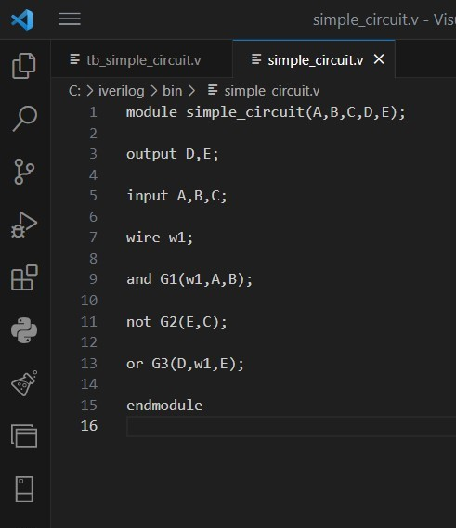

1. Paste the Screen Shot of the VVP command output

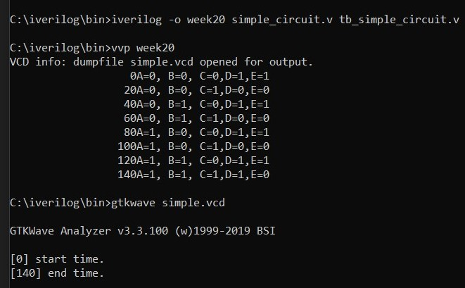

1. Paste the Screen shot of the GTKWave form

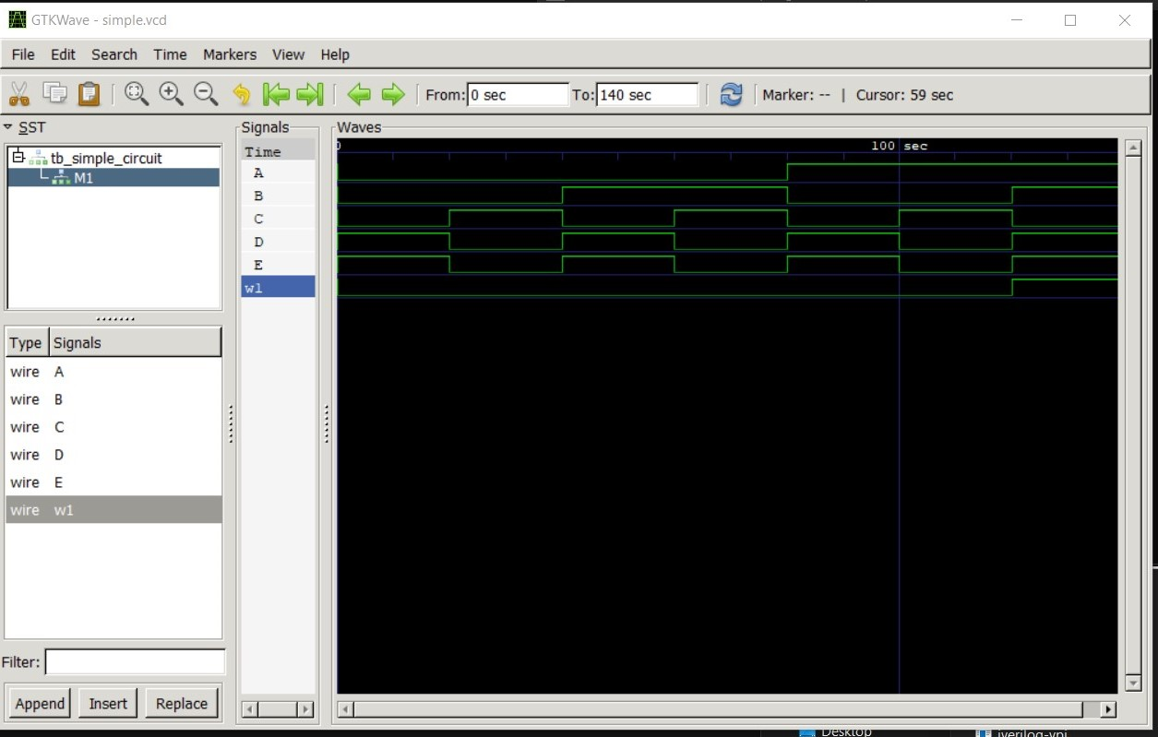

1. Include relevant Truth Table

|  |  |  |  |  |
| --- | --- | --- | --- | --- |
| A | B | C | D | E |
| 0 | 0 | 0 | 1 | 1 |
| 0 | 0 | 1 | 0 | 0 |
| 0 | 1 | 0 | 1 | 1 |
| 0 | 1 | 1 | 0 | 0 |
| 1 | 0 | 0 | 1 | 1 |
| 1 | 0 | 1 | 0 | 0 |
| 1 | 1 | 0 | 1 | 1 |
| 1 | 1 | 1 | 1 | 0 |

Week#__2_________

Program Number: ___2____

Title of the Program

CIRCUIT1

Aim:

**WRITE A VERILOG PROGRAM TO MODEL THE GIVEN CIRCUIT1. GENERATE THE VVP OUTPUT AND VIEW THE SIMULATION WAVEFORM USING GTKWAVE.VERIFY THE OUTPUT AND WAVEFORM WITH THE RELEVANT TRUTH TABLE**

1. Paste the Screen Shot of the source code

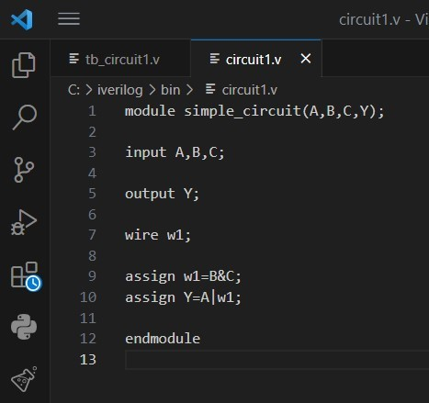

1. Paste the Screen Shot of the VVP command output

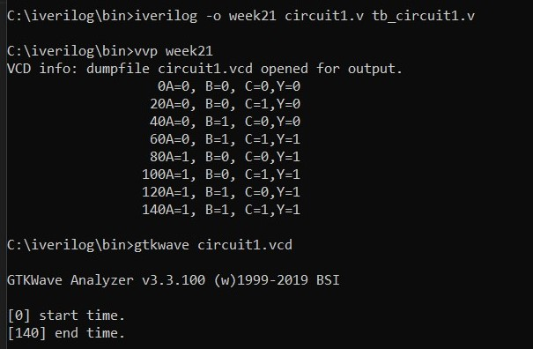

1. Paste the Screen shot of the GTKWave form

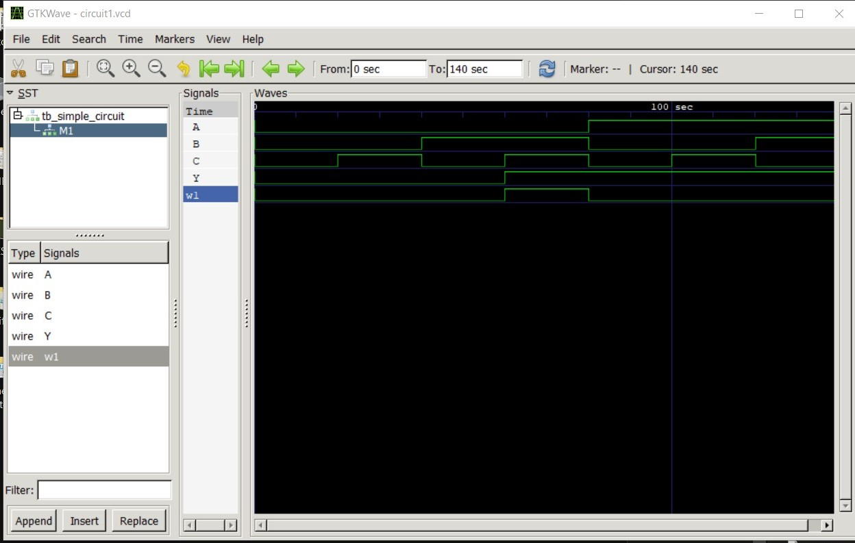

1. Include relevant Truth Table

|  |  |  |  |
| --- | --- | --- | --- |
| A | B | C | Y |
| 0 | 0 | 0 | 0 |
| 0 | 0 | 1 | 0 |
| 0 | 1 | 0 | 0 |
| 0 | 1 | 1 | 1 |
| 1 | 0 | 0 | 1 |
| 1 | 0 | 1 | 1 |
| 1 | 1 | 0 | 1 |
| 1 | 1 | 1 | 1 |

Week#__2_________

Program Number: ___3____

Title of the Program

CIRCUIT2

Aim:

**WRITE A VERILOG PROGRAM TO MODEL THE GIVEN CIRCUIT2. GENERATE THE VVP OUTPUT AND VIEW THE SIMULATION WAVEFORM USING GTKWAVE.VERIFY THE OUTPUT AND WAVEFORM WITH THE RELEVANT TRUTH TABLE**

1. Paste the Screen Shot of the source code

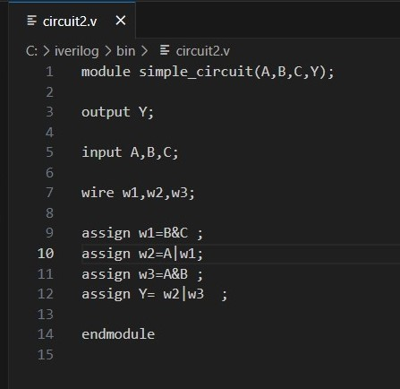

1. Paste the Screen Shot of the VVP command output

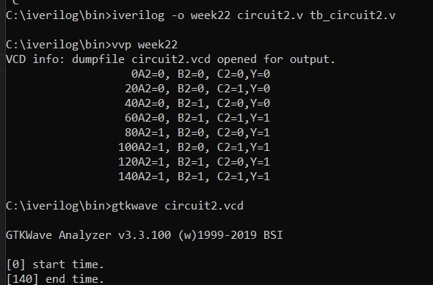

1. Paste the Screen shot of the GTKWave form

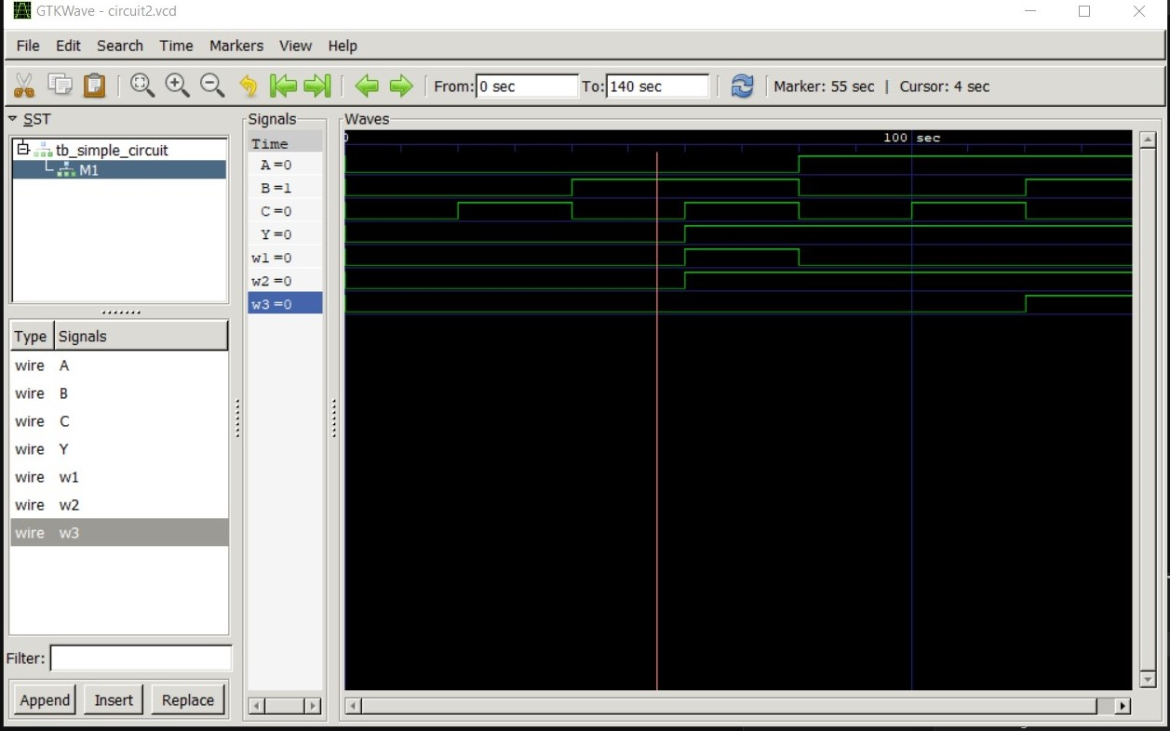

1. Include relevant Truth Table

|  |  |  |  |
| --- | --- | --- | --- |
| A | B | C | Y |
| 0 | 0 | 0 | 0 |
| 0 | 0 | 1 | 0 |
| 0 | 1 | 0 | 0 |
| 0 | 1 | 1 | 1 |
| 1 | 0 | 0 | 1 |
| 1 | 0 | 1 | 1 |
| 1 | 1 | 0 | 1 |
| 1 | 1 | 1 | 1 |

**Disclaimer:**

* The programs and output submitted is duly written, verified and executed my me.
* I have not copied from any of my peers nor from the external resource such as internet.
* If found plagiarized, I will abide with the disciplinary action of the University.

Signature:

Name: Gurram Shreya

SRN: PES2UG22CS209

Section: D:

Date: 17-08-2023